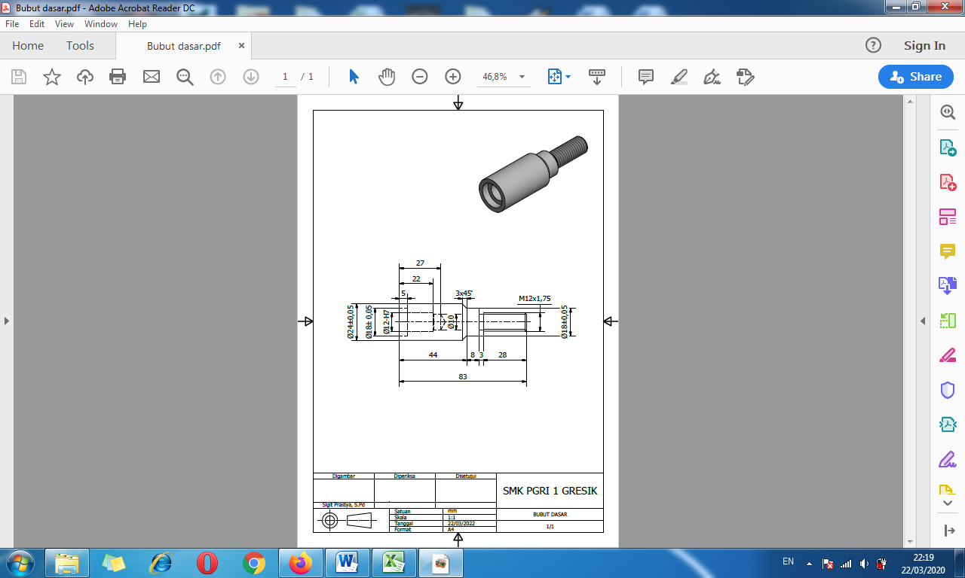

|  |  |  |  |  |  |  |  |  |  |  |  |  |  |  |  |  |  |  |
| --- | --- | --- | --- | --- | --- | --- | --- | --- | --- | --- | --- | --- | --- | --- | --- | --- | --- | --- |
|  |  | **Tugas Pribadi** pengganti praktik mesin bubut kelas X TP 8, Senin, 23 Maret 2020.  Buatlah langkah kerja pengerjaan benda kerja bubut (seperti tertera pada gambar kerja) secara lengkap dengan mengisi tabel berikut! | | | | | | | | | | | | | | | | |
|  |  | Pertanyaan lebih lanjut dapat menghubungi 081310056212 via whatsapp. | | | | | | | | | | | | | | | | |
|  |  | |  |  |  |  |  |  |  |  |  | |  | |  | |  |  |
| ***No.*** | ***Gambar sket (gambar menggunakan penggaris)*** | | ***Langkah pengerjaan*** | | ***Alat potong yang digunakan*** | | | | | ***Kecepatan potong (mm/s)*** | ***Kecepatan spindel (rpm)*** | | ***Waktu (menit)*** | |  | |
| ***K3*** | |
|  |  | |  | |  | | | | |  |  | |  | |  | |
|  |  | |  | |  | | | | |  |  | |  | |  | |
|  |  | |  | |  | | | | |  |  | |  | |  | |
|  |  | |  | |  | | | | |  |  | |  | |  | |
|  |  | |  | |  | | | | |  |  | |  | |  | |
|  |  | |  | |  | | | | |  |  | |  | |  | |
|  |  | |  | |  | | | | |  |  | |  | |  | |
|  |  | |  | |  | | | | |  |  | |  | |  | |
|  |  | |  | |  | | | | |  |  | |  | |  | |
|  |  | |  | |  | | | | |  |  | |  | |  | |
|  |  | |  | |  | | | | |  |  | |  | |  | |
|  |  | |  | |  | | | | |  |  | |  | |  | |
|  |  | |  | |  | | | | |  |  | |  | |  | |
|  |  | |  | |  | | | | |  |  | |  | |  | |
|  |  | |  | |  | | | | |  |  | |  | |  | |
|  |  | |  | |  | | | | |  |  | |  | |  | |
|  |  | |  |  |  |  |  |  |  |  |  | |  | |  | |  |  |
|  |  | |  |  |  |  |  |  |  |  | ***Gresik, … Maret 2020*** | | | |  | |  |  |
|  |  | |  |  |  |  |  |  |  |  | ***Orang tua siswa*** | | | |  | |  |  |
|  |  | |  |  |  |  |  |  |  |  |  | | |  | |  |  |  |
|  |  | |  |  |  |  |  |  |  |  | (………………………………..) | | |  | |  |  |  |
|  |  | |  |  |  |  |  |  |  |  |  | | |  | |  |  |  |
|  |  | |  |  |  |  |  |  |  |  |  |  | | | | | |  |